Question
Develop a SystemC simulation for an HVAC system and evaluate synchronization with real implementation.
Real implementation demonstrated using Arduino Uno in Wokwi with a potentiometer as the temperature sensor, LED as the cooling fan, and a 16x2 LCD for status display.

Aim
To implement an HVAC controller that monitors temperature, displays the temperature and fan status on a 16×2 LCD, and automatically turns the cooling fan ON or OFF based on a threshold value.

Algorithm
1. Initialize the LCD, Serial Monitor, LED, and analog temperature input.
2. Read the potentiometer value from analog pin A0.
3. Convert the analog value into a temperature range (0–50°C).
4. Display the current temperature on the LCD.
5. Compare the temperature with the threshold (30°C).
6. If temperature is greater than 30°C, turn the fan (LED) ON and display 'Fan: ON'.
7. Otherwise, turn the fan OFF and display 'Fan: OFF'.
8. Print the temperature and fan status to the Serial Monitor.
9. Repeat the process every second.

Analysis
The potentiometer simulates the HVAC temperature sensor. The Arduino periodically samples the analog input, updates the LCD with the current temperature, and compares the value against a 30°C threshold. When the threshold is exceeded, the LED representing the cooling fan is switched ON immediately; otherwise it remains OFF. This demonstrates synchronization between sensor acquisition, controller decision-making, display update, and actuator response in a real embedded implementation.

Embedded C Program
#include <LiquidCrystal.h>
LiquidCrystal lcd(12,11,5,4,3,2);
const int tempPin=A0;
const int fanLED=8;
void setup(){
pinMode(fanLED,OUTPUT);
lcd.begin(16,2);
Serial.begin(9600);
lcd.print("HVAC SYSTEM");
lcd.setCursor(0,1);
lcd.print("Starting...");
delay(2000);
lcd.clear();
}
void loop(){
int sensorValue=analogRead(tempPin);
int temperature=map(sensorValue,0,1023,0,50);
lcd.clear();
lcd.setCursor(0,0);
lcd.print("Temp:");
lcd.print(temperature);
lcd.write((byte)223);
lcd.print("C");
if(temperature>30){
digitalWrite(fanLED,HIGH);
lcd.setCursor(0,1);
lcd.print("Fan : ON");
Serial.print("Temperature = ");
Serial.print(temperature);
Serial.println(" C | Fan ON");
}else{
digitalWrite(fanLED,LOW);
lcd.setCursor(0,1);
lcd.print("Fan : OFF");
Serial.print("Temperature = ");
Serial.print(temperature);
Serial.println(" C | Fan OFF");
}
delay(1000);
}

Expected Output
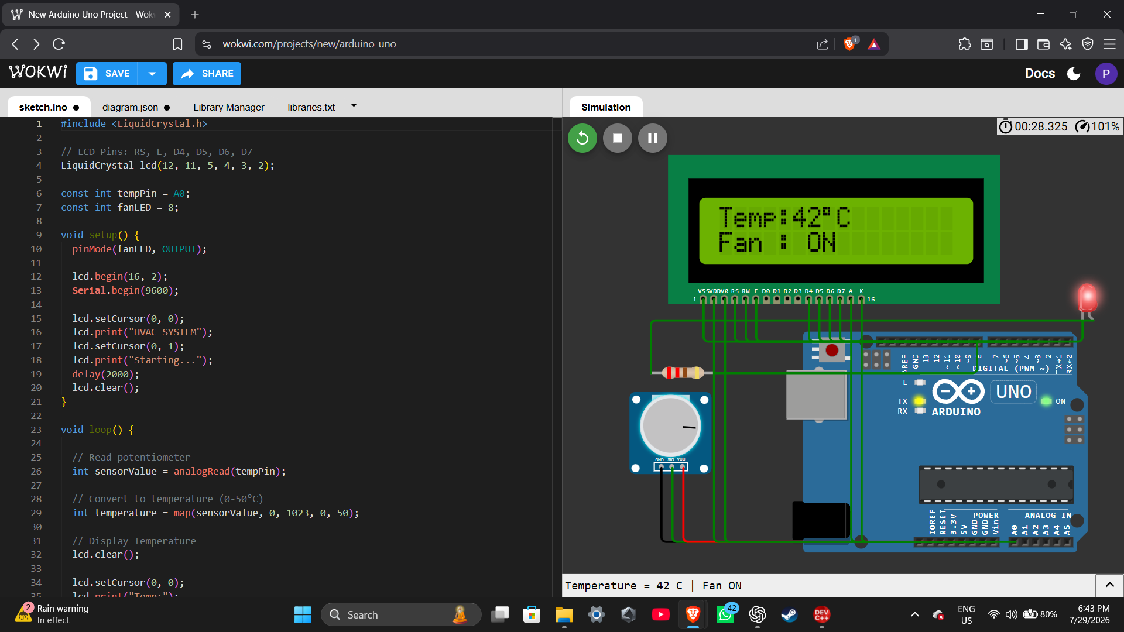
Figure: Wokwi implementation showing the LCD displaying the current temperature and fan status, with the LED acting as the cooling fan.

Result
The HVAC controller was successfully implemented in Wokwi. The system continuously monitors the simulated temperature, displays the temperature and fan status on the LCD, updates the Serial Monitor, and automatically controls the fan based on the predefined threshold. The implementation demonstrates the synchronization of sensing, processing, display, and actuator control in an embedded system.

